AI-powered FAQ and chatbot platform

1. Proposal Overview
I propose building the core pipeline of an AI-powered FAQ and chatbot platform, designed as an enterprise-grade knowledge system. The platform will allow teams to upload and manage knowledge content through a centralized admin interface. This content will be asynchronously processed and indexed using a Retrieval-Augmented Generation (RAG) approach backed by a locally hosted AI model. The system will expose a secure, read-only FAQ and chatbot interface consumed via a plug-and-play React Native SDK.

2. Capstone Objective
The primary objective of this capstone is to provide end-to-end engineering exposure for a senior engineer, focusing on:
- Microservices architecture and service boundaries
- Event-driven processing using Kafka/SNS Queue
- Secure public API design (API keys + request signing)
- Hybrid database usage (relational/non-relational + vector)
- AI system integration using RAG
- Observability and failure handling
The FAQ experience is the consumer use case, while the core learning lies in building and operating the backend system.

3. Scope
- API Gateway for public and internal access
- Authentication & tenant management service
- Content ingestion service with Kafka/SNS Queue-based async processing
- Embedding and vector indexing service
- RAG-based AI query service
- Read-optimized FAQ API
- React Native SDK as the consumer interface
- Structured logging, metrics, and basic tracing
- Analytics & reporting service

4. Technical Architecture (High Level)
The system will be built as a set of independently deployable services, communicating via HTTP and Kafka/Queue. Content ingestion and AI processing are decoupled from consumption, allowing the system to scale and evolve.
Key architectural characteristics:
- Event-driven ingestion and indexing
- Tenant-isolated data and access
- Read/write separation
- AI responses grounded in verified content
- Production-oriented observability

5. Security & Access Model
- Public APIs secured using API key + HMAC-signed requests
- Secrets never transmitted over the network
- Short replay windows and rate limiting
- Read-only access for SDK consumers
- Admin-only write operations

6. Deliverable
The final deliverable is a React Native SDK that can be integrated into any mobile app to:
- Render FAQs
- Query the AI chatbot
- Automatically reflect content updates from the platform

6. Screens
1. Signup -
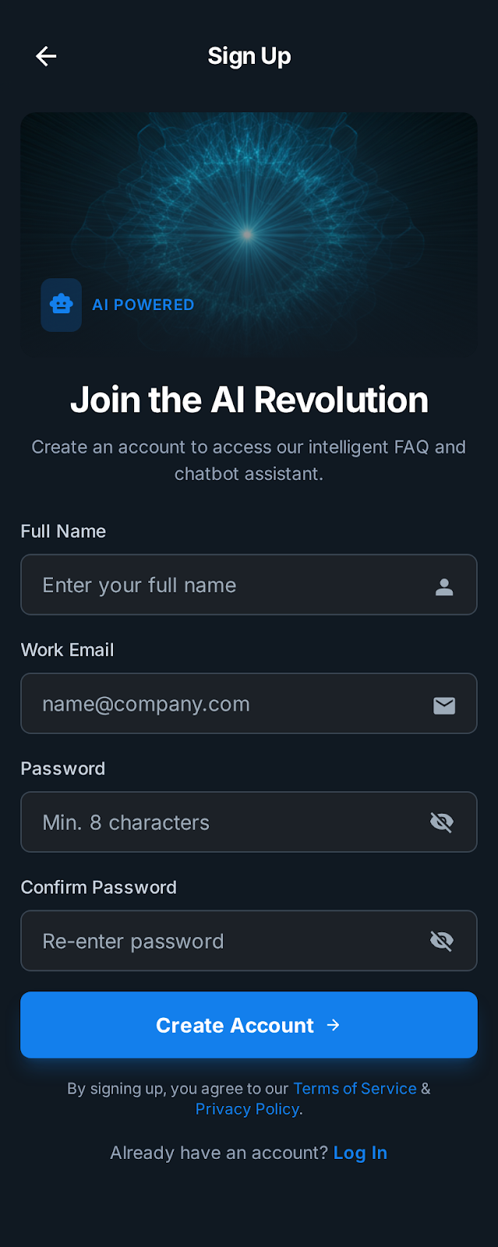

2. Login
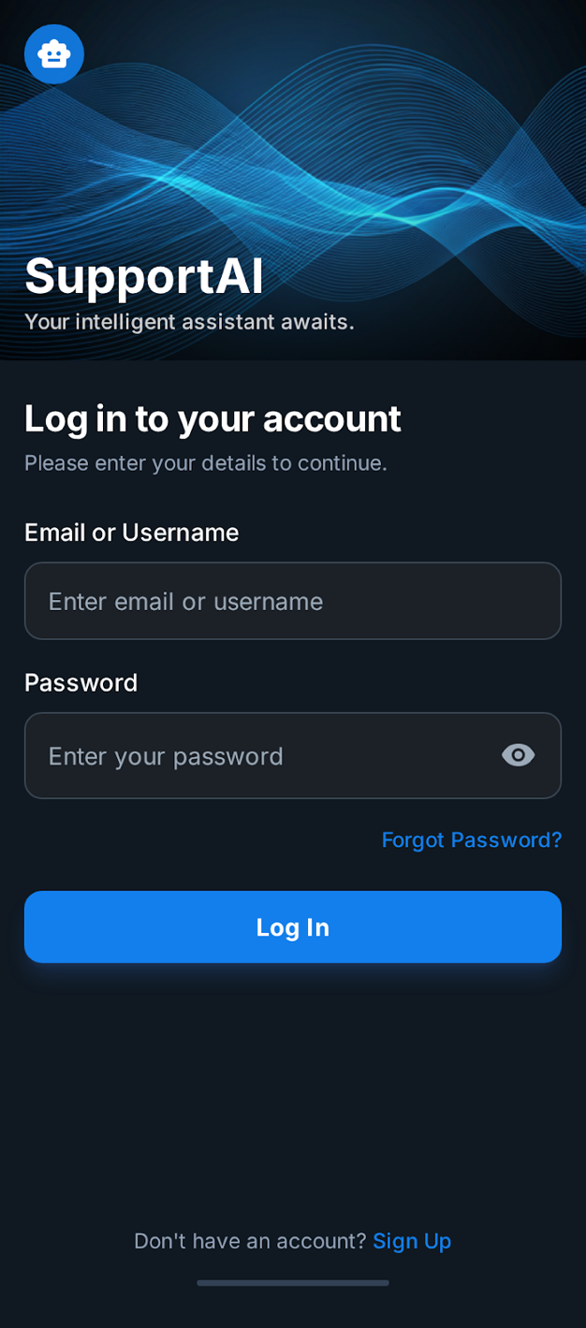

3. Admin only – Dashboard to Upload
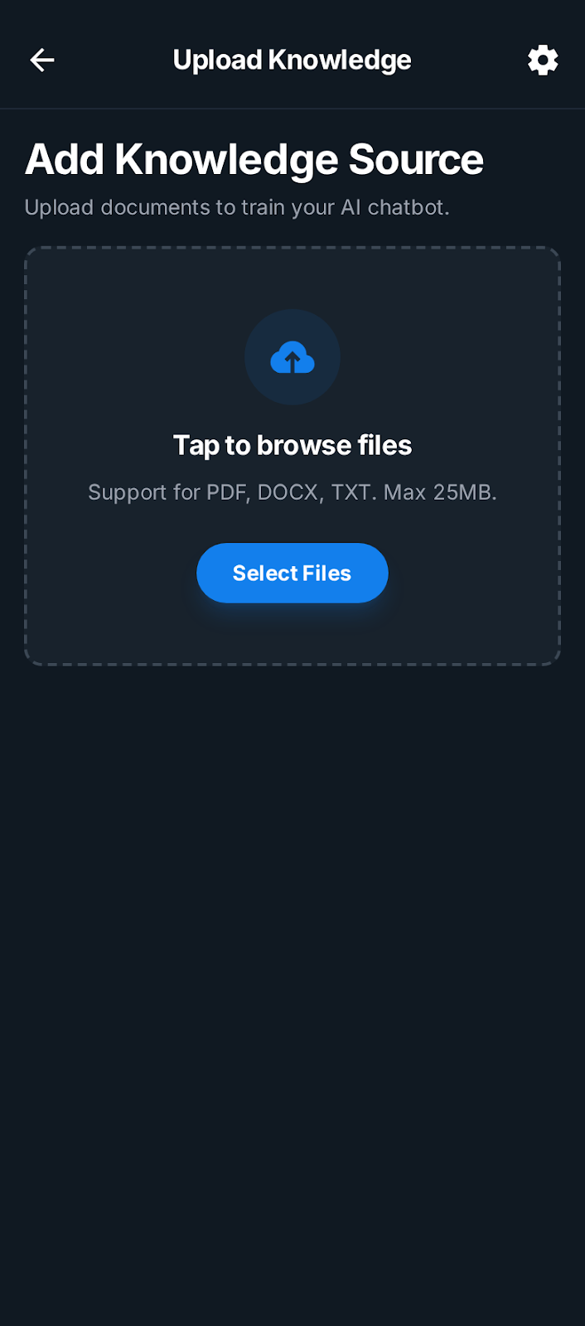

4. FAQs ( optional )
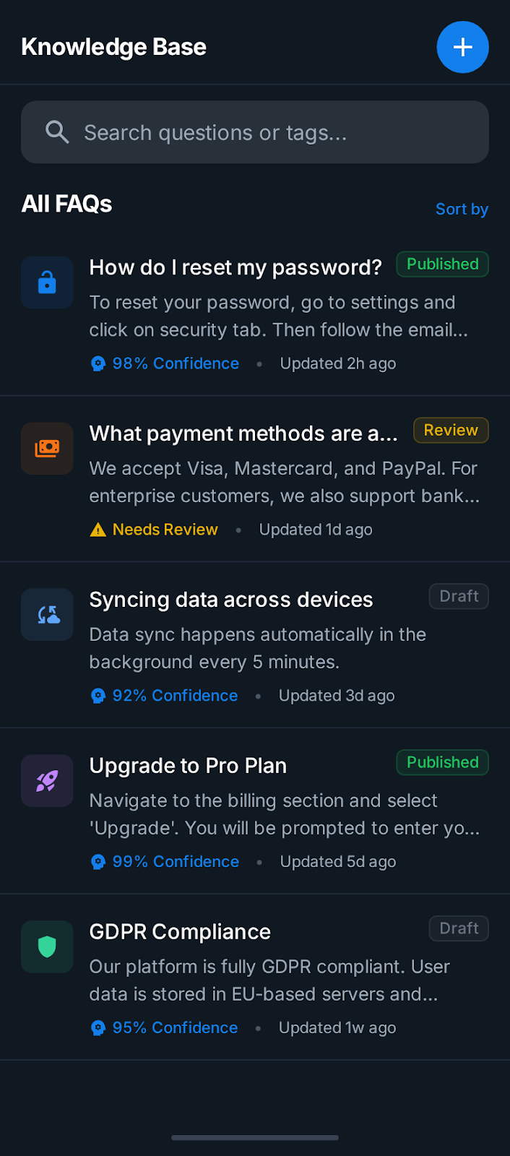

5. Chat Window
